Fall 2021 CS 687 Capstone Project

Online Vaccine Scheduler

Anil Erturk

Advisor: Dr. Ahreum Ju, Dr. Sam Chung

MS in Computer Science  
School of Technology & Computing (STC)

City University of Seattle (CityU)

erturkanil@cityuniversity.edu, juahreum@cityu.edu, chungsam@cityu.edu

**Abstract**

Factors such as social distancing affect the transmissibility of the coronavirus. Using these factors, public health policies are being crafted everywhere. This online vaccine schedulers project aims to help unvaccinated people socially distance more by giving them the necessary tools and helping decrease the burden on the healthcare system. One of the things most unvaccinated people will do is get vaccinated. So, giving them the capability to remotely schedule/view/edit/cancel vaccine appointments via an MVC web application will allow them to socially distance more.

**Keywords:** Java, Servlet, JSP, Spring, MySQL

**1.** **INTRODUCTION**

**Problem Statement**

Unvaccinated physical contact causes coronavirus and other pathogens to be spread more. Carrying the scheduling of the vaccines online will remove this unvaccinated physical contact. Which will lower the virus transmission. (Price et al., 2021) Also, websites can serve multiple clients at once. This makes websites a better solution than phone calls for a vaccine scheduling system.

“Can we allow unvaccinated people to socially distance more by giving them the necessary tools?” is the problem statement. Getting vaccinated is a common denominator for unvaccinated people. So giving them remote tools for it will increase social distancing which is shown to decrease transmission. The specific tool that will be used is a dynamic website. Also known as a web application or a web app. This can be used by people to schedule their vaccination appointments remotely and without the need for call center employees.

**Motivation**

The motivation for the project is reducing the spread of coronavirus by allowing people to schedule their vaccination appointments online. And therefore lowering the burden on the healthcare system. (Cowling et al., 2020)

Improving the existing work by adding more remote features such as viewing, editing, and deleting appointments will give people more remote capabilities and the option to socially distance.

**Approach**

The requirements were very similar for all previous work. The user stories for vaccination appointment systems are expectedly similar because they all do the same work. They do have some slight differences such as asking for symptoms and showing only available stores for the selected vaccine. The vaccine scheduling system can be improved with editable appointments.

**Conclusions**

The requirements for the improved vaccine scheduling system are being able to view, edit, and delete the appointment on top of the features other implementations already have such as creating an appointment, filtering by zipcode, etc. When people have more remote capabilities, they will be more likely to use them, and this will allow the project to fulfill its purpose of giving the people the tools to socially distance.

**2. BACKGROUND**

The literature also agrees that there are multiple factors that affect the transmissibility of airborne viruses. (Lin et al., 2020l; Zhu et al., 2020). Governments use these factors to come up with public health measures. Social distancing is one of these public health measures (Park et al., 2020). The online vaccine scheduler is part of social distancing.

Park et al., (2020) show that noninvasive measures such as voluntary measures can be enough to curb coronavirus. Cowling et al., (2020) points out the importance of multi-layered public health policies. Price et al., (2021) also show that social distancing works.

Sallis et al., (2020) conclude that active muscles produce chemicals that improve immune functioning.

**3*.* RELATED WORK**

Related work is from companies such as Safeway, CVS, and Rite Aid. They are similar since the requirements for an online vaccination system are very similar. The backend/server-side technology they use is not obvious since we the client can only see the front end. But we know that they are all web applications. A call center version would require many employees. Web applications can serve many people at the same time without a need for employees. All the applications offer multiple vaccines, not just coronavirus vaccines. And they all display vaccinations locations based on distance (filter by zip code). There are differences between the applications though. Some ask for symptoms, some don’t. Some show only locations that have the selected vaccine, some don’t (filter by vaccine). View, edit, and delete the appointment features would make an improvement over these projects.

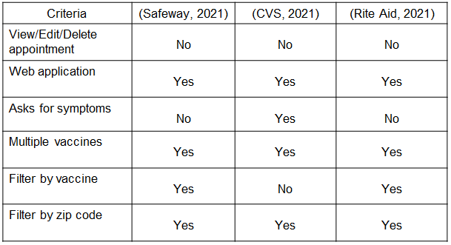

**4.** **APPROACH**

The study chose a web application implementation over a call center implementation because web applications do not require as many employees and can still serve multiple clients at once. Java programming language has web application frameworks that can handle HTTP requests and responses. The Servlet technology forms the foundation of JSP and Spring technologies. Servlet is the controller part of the MVC web application whereas JSP is the view part of the MVC web application. The MVC web application structure was deemed the correct solution for the problem because it allows for modularization and separation of concern (SoC). We have also used MySQL and Apache Tomcat for database and web container.

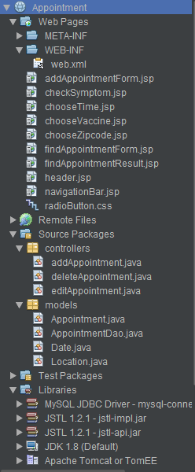



The figure above displays the views (web pages), controllers (business logic), and models (database), as well as the DAO (Database Access Object) which is named AppointmentDAO. The DAO file helps with database access.

Some views are completely static and some views are partially dynamic. For example, the client first chooses the zip code and then is shown the vaccination locations for those zip codes. Those locations on the web page were generated dynamically. There are also remote and local CSS files.

There are three controllers. They are responsible for adding, editing, and deleting appointments.

There are three models. Appointment, location, and date. There is also the AppointmentDao which is the DAO for the project.

**5.** **DATA COLLECTION**

There are eight metrics we used to differentiate the relevant work and this study. They are qualitative metrics that correspond to features for the website. The requirements are similar for online vaccine schedulers but there are still differences such as asking for symptoms.

The most important criteria are being able to view, edit, and delete your appointments. Which only this study has. Only CVS and this study ask for symptoms. All works are web applications and have multiple vaccines. And they all list locations based on zip code. And all but CVS show stores with the selected vaccine.

This study has seven of the eight metrics. View, edit, and delete appointments, web app, ask symptoms, multiple vaccines. filter by zip code. One is left to future work. Which is adding the location dataset and filtering them by the selected vaccine.

**6.** **DATA ANALYSIS & CONCLUSION**

The criteria used to collect data were features for the website. Therefore the implementations with more features are better since they give more remote capabilities to especially unvaccinated people which allows for more social distancing and lower coronavirus transmissions. The key feature added in this study was giving the clients an ID for the appointment for them to view, edit, and delete the appointment.

**9.** **FUTURE WORK**

Finding and adding the dataset of vaccination locations to the database. This will allow the clients to see up to date and real vaccination locations. This data will also contain vaccines the location provides. Filtering locations based on the vaccine selected, similar to how the locations are presented to the client based on the selected zip code.

**REFERENCE**

Park, S. W., Sun, K., Viboud, C., Grenfell, B. T., & Dushoff, J. (2020). Potential Role of Social Distancing in Mitigating Spread of Coronavirus Disease, South Korea. Emerging Infectious Diseases, 26(11), 2697–2700.

Zhu, l., Liu, X., Huang, H., Llaguno, R. D., Lazo, M. M. L., Gaggero, A., Rifo, R., Patino, L., Avellan, M., Diringer, B., Huang, Q., & Zhu, Y. (2020). Meteorological impact on the COVID-19 pandemic: A study across eight severely affected regions in South America. Science of The Total Environment 744.

Okten, I. O., Gollwitzer, A., & Oettingen, G. (2020). Gender differences in preventing the spread of coronavirus. Behavioral science & policy association.

Mallapaty, S. (2020). How do children spread the coronavirus? The science still isn't clear. nature, 581(7807), 1749–1751.

Kwon, Y., Cho, H., Lee, Y., Bae, G., Lee, S. (2010). Relationship between intention of novel influenza A (H1N1) vaccination and vaccination coverage rate. Vaccine, 29(2), 161–165.

Larson, G. S., Baseler, B.R., Hoover, M. L., Pierson, J. F., Tegli, K. J., Johnson, M. P., Kieh, M. W. S., McNay, L. A., & Njoh, W. S. (2017). Conventional Wisdom versus Actual Outcomes: Challenges in the Conduct of an Ebola Vaccine Trial in Liberia during the International Public Health Emergency. The american journal of topical medicine and hygine, 97(1), 10–15.

Jiang, H. D. C., Wang, Z., Wang, L., Wang, W. J., Wang, H., Deng, P., Jia, S., Y., Liu, Z. H., & Zhu, F. C. (2020). Exploration and application of a novel attempt to recruit participants in clinical trials of vaccines under the emergency. Chinese Journal of Preventive Medicine, 54(9), 963–967.

Bukhari, Q., & Jameel, Y. (2020). Will Coronavirus Pandemic Diminish by Summer?

Price, G., & Holm, E. (2021). The Effect of Social Distancing on the Early Spread of the Novel Coronavirus. Social Science Quarterly

Sallis, J. F., Adlakha, D., Oyeyemi, A., & Salvo, (2020). An international physical activity and public health research agenda to inform coronavirus disease-2019 policies and practices. The Journal of Sport and Health Sciences, 9(4), 328–334.